Configuring Motion

Don't bother trying to run Motion yet as it won't work until you've updated the configuration file :)

You can open the configuration file in edit mode by entering:

sudo nano ~/.motion/motion.conf

[Nano](https://www.nano-editor.org/dist/v2.2/nano.html) is a simple Linux text editor allowing you to edit and search text files. Feel free to use an alternative text editor if you wish.

Below is a list of the parameters that I have tweaked for my setup. [Consult the manual](http://htmlpreview.github.io/?https://github.com/Motion-Project/motion/blob/master/motion_guide.html" \l "Configuration_OptionsDetail) for comprehensive documentation of these and other Motion parameters.  Note that the rest of these blog will assume that you have set these values as I have specified.

1. Uncomment the *mmalcam\_name vc. ril. camera*parameter.
2. Uncomment*target\_dir* and change it's associated value to ’/home/pi/Documents/motion’
3. Ensure that *ffmpeg\_output\_movies* is set to ‘on’ to record video
4. Set *stream\_localhost* to ‘off’
5. Set *webcontrol\_localhost* to 'off’
6. Set *width* to ‘640’ and *height* to ‘480’
7. Set *locate\_motion\_mode*to ‘preview’
8. Set *locate\_motion\_style* to ‘redbox’
9. Set *event\_gap* to '10'
10. Set *output\_pictures* to 'center'
11. Set *quality* to '80'
12. Set *text\_changes* to 'on'

Feel free to play around with the configuration parameters to get a feel for what they do.  Be careful to keep a record of the parameters you have changed, in case you mess up and need to start again. Remember that you always have a clean copy of the config file at  */etc/motion/motion.conf*.

**Configuring Motion to send Email**

Here you'll need to make a small change to your Motion configuration file.

sudo nano ~/.motion/motion.conf

You'll be updating the *on\_picture\_save* parameter. Uncomment it and change it's value as follows (updating the recipientEmailAddress to the email at which you want to receive alerts):

mpack -s "Your Security Camera has detected Motion!" %f [recipientEmailAddress]

What happens here is that Motion will call this command each time a new image snapshot is saved to the *target\_dir*directory. The %f variable contains the full path to the file.

Save the configuration file, restart Motion and voila! You should now be receiving email notifications each time Motion detects a motion event.

Housekeeping Functions

**Ensuring Motion startups up on Reboot**

The easiest way to ensure Motion starts up on reboot is to add it to the [rc.local](https://www.raspberrypi.org/documentation/linux/usage/rc-local.md)file. This is a simple as adding the following command - assuming that you have specified the configuration file as outlined in this blogpost:

motion -c ~/.motion/motion.conf

**Removing old files**

Over time there is a danger that your SD card will fill up with old images.  Therefore I strongly recommend that you create an [automated cronjob](https://www.raspberrypi.org/documentation/linux/usage/cron.md)to periodically remove all images from the output directory specified in the Motions configuration (the value to the key *target\_dir*)*.*

Evaluating The Result - Did the Security Camera work?

So does my camera do the job it was meant to do?  Definitely!  Here are some examples of the alerts that I have been sent by the camera.

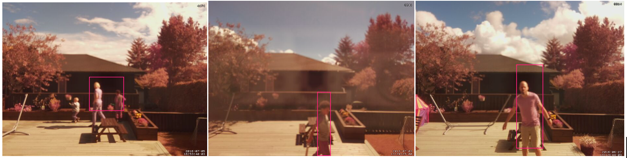*Examples of the camera successfully detecting humans in my garden*

In addition the streaming video works perfectly, making it easy to check the video stream each time I get alerts. By setting port forwarding in my home router I have exposed the live stream to the web and can now view it from my iPhone.

The Camera is meant to run 24/7, and was recently up for 4 weeks without a single problem while myself and my family where on holiday in England. In addition to receiving alerts via email, we used the streaming video on a daily basis to see how the weather was in Oslo (and to check that my brother in law was watering the flowers as agreed).

There are many use cases for this kind of project.  It can be used for wildlife watching, pet monitoring or even to tell you when your kids come home from school!

**Minor Issues**

I have two minor problems with the solution, which are both easily resolved:

1. The Pi NoIR camera works well in low light, but really needs an IR light source to perform at night. I haven't got around to picking one up yet, but they are easy to get hold of online.
2. The camera is mounted inside the house looking outwards.There is a small gap between the lens of the camera and the glass, which allows for reflections to appear when it is dark outside and the living room light is on. This can be resolved by placing some cardboard or tape around the edges of the ZeroView camera mount, which would stop the light pollution hitting the glass right in front of the camera.

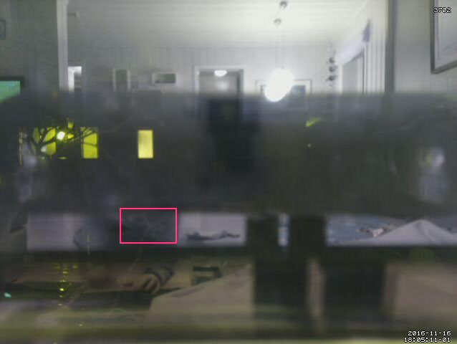Example of light pollution affecting the pictures from the Camera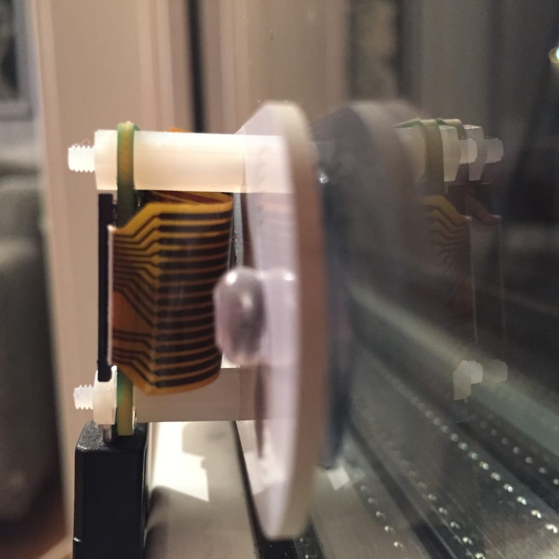Here you can make out the gap between the ZeroView/Camera and the glass window

**Other Issues**

A more difficult issue to resolve was that of *false positives*. The Motion software algorithm for detecting movement is based on the amount of pixels changing from frame to frame.  In practice this meant that I received alerts when the neighbours cat paid us a visit, or on partly overcast days when the shadows in the garden quickly moved and changed.  Rain running down the window was also an issue.

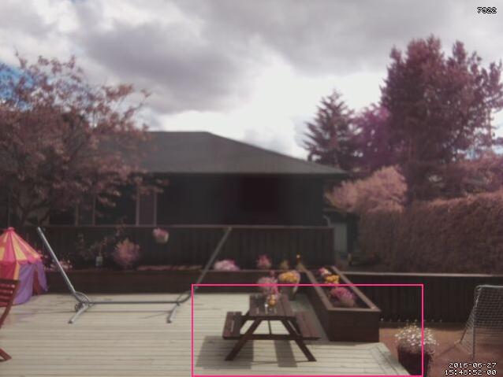Example of false positive due to moving shadows

On some days I received 50 alert emails due to these false positives, which tended to undermine the usefulness of the camera. Motion allows you to tweak the amount of pixels needed to trigger an alert, but then you run the risk of making the camera less effective.

Conclusion and next steps

Over all I was very happy with the result. The camera worked as designed and satisfied our original requirements.

The false positives issue was the only real problem. I therefore decided to find a solution to this!

In my next blog post I show [how I solved the problem of false positives by using Image Analysis and Amazon Web Services](https://www.bouvet.no/bouvet-deler/utbrudd/smarten-up-your-pi-zero-web-camera-with-image-analysis-and-amazon-web-services-part-1).

Until then, thanks for reading!  If you have put together a similar project, or have any questions about this blog, or find any errors in the code then feel free to tweet me [@markawest](https://twitter.com/markawest) or post a comment below.